**Serverless Microservices reference architecture**

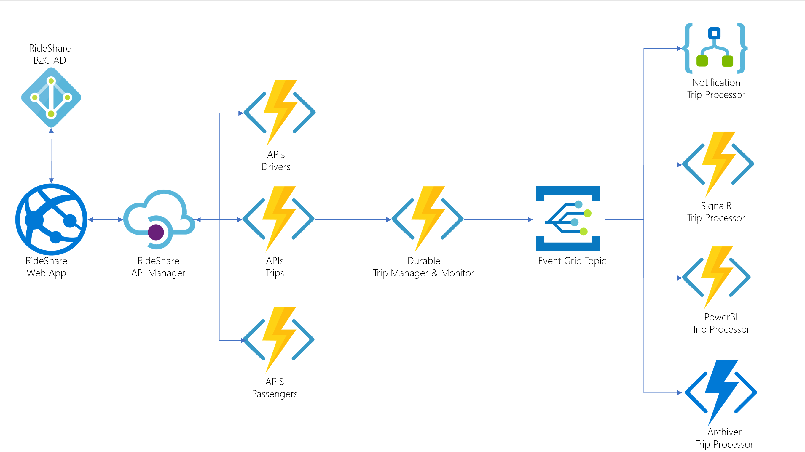

* **Customer scenario:**

Relecloud is a new company in the cloud services industry, focused on building innovative applications quickly and efficiently. They have a distributed workforce and prefer to focus on developing applications rather than managing infrastructure. Their latest project is a ride-sharing application that aims to compete with popular services by offering competitive rates and improved communication between passengers and drivers.

To achieve their goals, Relecloud's technical leaders are keen on adopting the latest technologies and buzzwords, with serverless being a hot trend. Serverless platforms offer consumption-based pricing, which means they only pay for the resources they use, making it cost-effective. Additionally, serverless platforms enable rapid prototyping and development by reducing the amount of code and configuration needed, and they automatically handle scaling to meet demand.

For their ride-sharing application, Relecloud has chosen to build on Azure's serverless components due to their versatility and unique capabilities, like Durable Functions for orchestrating serverless activities. They also want to explore using the microservices pattern, which complements Azure functions, API Management, and Event Grid, among other key services. This architecture allows them to break down the application into smaller, manageable pieces, making it easier to scale and maintain.

To ensure smooth operation and monitoring, Relecloud wants to implement comprehensive monitoring from the beginning, given the numerous components involved in their solution. They plan to use DevOps practices to automate continuous integration and deployment, streamlining the management of all the moving parts in their application.

In summary, Relecloud aims to leverage Azure's serverless offerings, microservices architecture, and DevOps practices to develop their ride-sharing application quickly, efficiently, and with the ability to scale to meet global demand. Their focus on innovation and using fully managed services allows them to concentrate on building the best application possible while leaving infrastructure management to the cloud platform.